E-CONTENT

MJMC, SEM-IV, PAPER-XIII (CC- 401)
Topic : Structure of a Typical Radio and TV Station

Date : 27-01-2020, TIME : 1.00 P.M.-2.00 P.M.

PREPARED BY : AMIT KUMAR

Structure of a Typical Radio Station

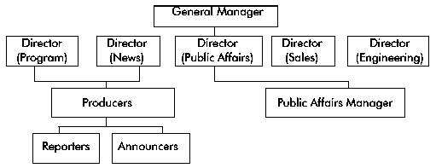
Structure of a Typical Radio Station
Reporters and producers will be the most visible to you. Target them as you would staff writers in a magazine. Also target the public affairs director/manager, news director and programme director as you would editors in a newspaper/news agency.

Structure of a Typical Television Station

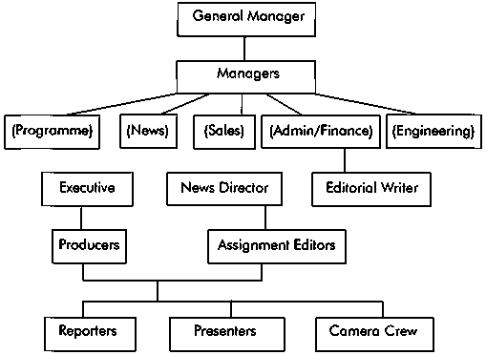
Structure of a Typical Television Station
Again, your primary targets here are the reporters, camera crew, presenters of popular talk-shows and producers. Cultivate them as you would the staff writers at a magazine and target the other higher-level personnel, especially executive producers and assignment editors, through media tours and media breakfasts/dinners.

